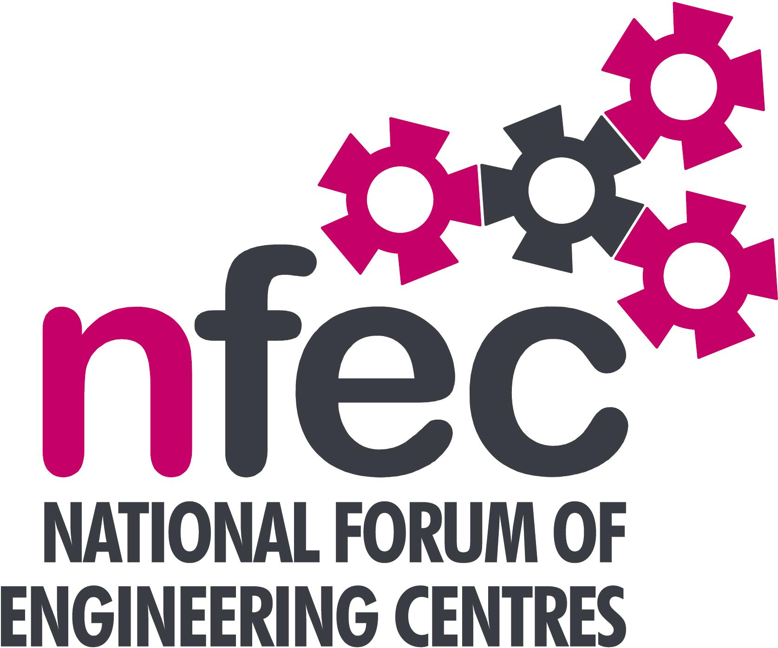
Midlands – NFEC Autumn 2016 Regional Seminar
Host: Neil Sambrook, Walsall College

Friday 21st October 2016, 10.15am – 15.00 (Coffee from 10.00am)
Venue: Green Lane Campus, Long Acre St, Walsall, WS2 8HX
Telephone Number: 01922 657000

Programme

- Welcome and Introduction to the Seminar | Kevin Whitehouse, NFEC Midlands Regional Coordinator and Birmingham Metropolitan College | 10.15
- Current matters of concern relating to quality, content, structure, management and delivery of programmes of training and education in Engineering (not included on Agenda) - an opportunity for open discussion with a focus to distill key issues and plans for addressing them.  - The Composites Technician Trailblazer Apprenticeship-“An opportunity  - Updates from Awarding Bodies – Current developments and general issues. | All Delegates / Kevin Whitehouse  Brian Thornton, National Composites Centre  Dean Jones, Trailblazer Chair, Rolls Royce  Dean O'Donoghue – AQA  David Lee – Pearson  EAL  C&G  OCR | 10.20  10.45  11.15
- Apprenticeship Trailblazer Initiative - Update and discussion on developments and experiences, to help highlight any common issues.  Tour of facilities  Lunch & Demonstrations by Exhibitors  - Update on an EU funded project to develop a Robotics qualification that can be rolled out internationally  - Plenary session – Issues to note and agreed actions for NFEC  - Date, Place and Topics for next Seminar  Close | Bob Millington, NFEC National Liaison  Provider input  Neil Sambrook  Paula Cresswell, Birmingham Metropolitan College  Kevin Whitehouse / Delegates  Kevin Whitehouse / Delegates | 11.45  12.30  13.00  13.45  14.30  14.45
Entry is free to this seminar for members or non-members present for a first attendance.There will be a charge for non members after this. A light buffet lunch will be provided and you will be able to see/discuss demonstrations of the latest available equipment and facilities for the delivery of learning in Engineering | To book your place: Email: admin@nfec.org.uk  Phone: 07759 901229

